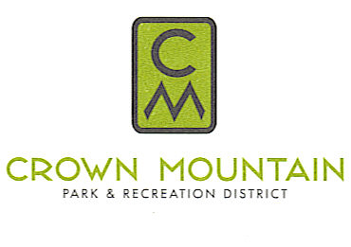
“Creating a Community Legacy through Parks and Recreation”
Board of Directors Meeting @ Bike Park Clubhouse
Thursday, October 17th@ 5pm (Executive Session)

Estimated Topics to Discuss Board Meeting
Time

Special board meeting:

5:00pm Call to order approval of the agenda

5:01pm Executive Session pursuant to C.R.S. § 24-6-402(4)(b) to receive legal advice regarding the District’s water rights

5:32pm Executive Session pursuant to C.R.S. § 24-6-402(4)( f)(I) to conduct the Executive Director’s review

5:50pm Review and possible approval of wage increases for the Executive Director

5:55pm Adjourn

